Here are my thoughts on comps:
1. 7106 Via Del Charro just closed 6/30/2015. It looks decent in the photos, but I saw it, and it needed plenty. You can tell in the one kitchen photo that it had a red counter with electric stove, white cabinets, and plum-colored walls.
The biggest benefit of my listing is that 90% of the house is fully remodeled. 7106 VDC sold for $2,900,000, but for comp purposes we should include the same $500,000 my sellers spent in remodeling costs that those buyers would have to endure to make that house truly comparable to my listing.
These big-bomber houses are too big, and the cost-per-sf metric is not a good measurement. Just about anyone can live in 4,000sf to 5,000sf, and any square footage on top of that shouldn't be counted at the same $/sf - it's usually just extra rooms that don't add much.
Summary: 7060 VDC offers the same effective base value as 7106 VDC, whose extra square footage was useless - but 7060 doesn't need the whole-house remodel.
http://www.sdlookup.com/MLS-150015429-7106_Via_Del_Charro_Rancho_Santa_Fe_CA_92067
2. 7103 Via Del Charro - REO that sold for $1,608,000, which is land value. The house is still being torn down today. If they rebuild it as the same size as my listing at 7060 VDC (which is 4,855sf) and keep the costs down to $200/sf, then 4,855sf x $200/sf = $971,000 + $1,608,000 = $2,579,000 and I still have two guest houses to include.
http://www.sdlookup.com/MLS-140019676-7103_Via_Del_Charro_Rancho_Santa_Fe_CA_92067
3. 7020 Via Del Charro - house next door that was built in 1973 and had been updated, not remodeled. It looked like an old house with new parts glued on. My listing looks more like a new house with high-end finishes - big difference. Sold for $2,550,000 after agent threw in $25,000 of commission.
http://www.sdlookup.com/MLS-140029393-7020_Via_Del_Charro_Rancho_Santa_Fe_CA_92067
4. 18102 Via Ascenso - A two-story house in the Groves with half the lot (not much usable land) - plus it was a short-sale - sold for $2,550,000.
http://www.sdlookup.com/MLS-150001060-18102_Via_Ascenso_Rancho_Santa_Fe_CA_92067
5. Same-sized house sold next door in La Cima for $2,600,000 off the MLS. It looked the same as it did when built in 1994, and it's not a horse property and doesn't have guest houses:
http://www.zillow.com/homedetails/6955-Rancho-La-Cima-Rancho-Santa-Fe-CA-92067/16731134_zpid/

6. If you allow me to include one Covenant property, this is it - same-sized house plus extra out-buildings on the same 2.7 acres - very similar to subject property. Sold for $2,950,000:
http://www.sdlookup.com/MLS-140036684-16259_Via_Del_Alba_Rancho_Santa_Fe_CA_92067

$2,795,000 list price is $337,000 UNDER the zestimate of $3,132,834.
64% of nearby homes are more expensive – and major remodels happening throughout the area:
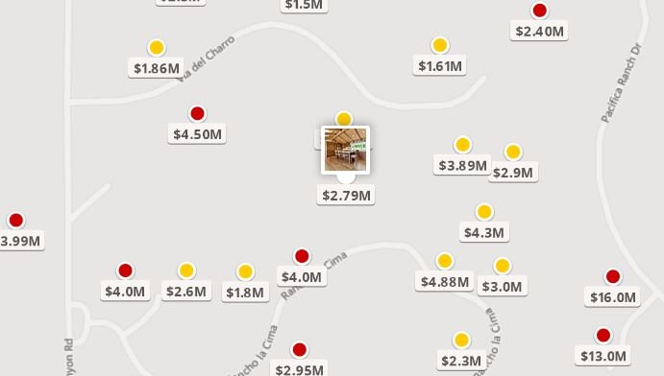
You should buy this home!
Jim Klinge, Broker #00873197 (858) 997-3801

